**Question 1**

**(a) Convert the 345 decimal number to**

**(i) Binary**

**Remainder  
2 | 345 1  
2 | 172 0  
2 | 86 0  
2 | 43 1  
2 | 21 1   
2 | 10 0  
2 | 5 1  
2 | 2 0  
 1**

**Ans: 0000 0001 0101 1001**

**(ii) Octal**

**Remainder**

**8 | 345 1  
8 | 43 3   
 5**

**Ans:531**

**(iii) Hexadecimal**

**Remainder**

**16 | 345 9  
16 | 21 5  
16 | 1**

**Ans: 0x159**

**B (i) 4568 + 7468  
  
 1 1  
 4 5 6 8  
 + 7 4 6 8  
--------------------  
 1 4 2 4**

**6 + 6 = 12  
12 – 8 = 4 therefore 12 is 4 for base of 8**

**5 + 4 + 1 = 10  
10 – 8 = 2 therefore 10 is 2 for base of 8**

**1 + 4 + 7 = 12  
12 – 8 = 4 therefore 12 is 4 for base of 8**

**Ans: 1424 for base of 8**

**B(ii) 10112 * 1012**

**1 0 1 1  
 x 1 0 1  
---------------------  
 1 0 1 1  
 0 0 0 0 0   
 1 0 1 1 0 0  
---------------------  
 1 1 0 1 1 1**

**Ans: 0011 0111  
Ans: 0000 0000 0011 0111**

**B(iii) F6B16 + BCE16**

**1 1  
 F 6 B 16  
 + B C E 16  
-------------------------  
 B 3 9**

**B + E = 11 + 14 = 25  
25 – 16 = 9 therefore 25 is 0x19**

**1 + 6 + C = 1 + 6 + 12 = 19  
19 – 16 = 3 therefore 19 is 0x13**

**1 + F + B = 1 + 15 + 11 = 27  
27 – 16 = 11 therefore 27 is 0x11**

**Ans: B3916**

**Question 3  
(a) The wavelength** λ **and frequency** f **of a sound wave are related by** λ f = v**, where** v **is the speed of the wave. Musicians refer different wavelengths or frequencies by their notes (A – G). Use the information in the following table to plot the frequency on the vertical axis of** 1/λ **on the horizontal axis.**

**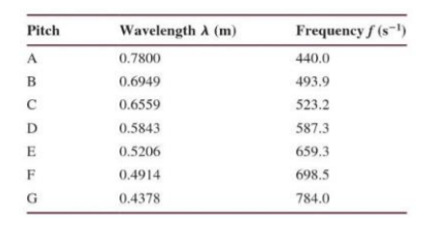  
Ans:**

frequency = [440.0 493.9 523.2 587.3 659.3 698.5 784.0];

wavelength = [0.7800 0.6949 0.6559 0.5843 0.5206 0.4914 0.4378]  
reciprocal = []  
for i=1:length(wavelength)  
 reciprocal = [reciprocal,1/wavelength(i)]  
end  
plot (reciprocal,frequency);  
xlabel (‘Wavelength’)  
ylabel (‘Frequency’)  
legend ({‘Frequency vs Wavelength’}, ‘Location’, ‘southeast’)

**Question 4  
(a) Write MatLab solution for the following conversion:  
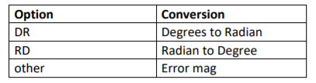  
Your solution must prompt user to input the option (DR or RD). If the option is DR, then ask for angle in degrees and the program displays the equivalent radians. If the option is RD then ask for the angle in radians then the program displays the equivalent degrees.  
Your program should be able to accept both scalar and matrix input.**

**The script should be keep running until no number is provided to convert.**

**Ans:**choice = input (‘Select Your choice (DR or RD) : ‘,’s’);  
while choice != ‘RD’ && choice!=’DR’  
 disp (“You Have Entered Wrong Keyword’);  
 choice = input (‘Select Your choice (DR or RD) : ‘,’s’);  
end  
if choice == ‘DR’  
 angle_in_degree = input (‘Please input Angle in degrees : ‘);  
 while isempty (angle_in_degree)  
 angle_in_degree = input (“Please input Angle in degrees : ‘);  
 end

angle_in_radian = angle_in_degree*pi/180;   
 disp (‘The Angle in radian is : ‘);  
 disp (angle_in_radian);  
end  
if choice == ‘RD’  
 angle_in_radian = input (‘Please inout Angle in radian : ‘);  
 while isempty (angle_in_radian)  
 angle_in_radian = input (‘Please input Angle in radian ; ‘);  
 end  
 angle_in_degree = angle_in_radian*180/pi;  
 disp (‘The Angle in Degrees is ; ‘);  
 disp (angle_in_degree);  
end

**Question 5**

**(B) The matrices A, B, C, D are shown below:**

**- 1 5 2 2  
 A = 3 -2 2 B = 0   
 3**

**2 -1 -2 0  
C = 3 5 D = 4 -1**

**Evaluate the following:  
(i) AB  
(ii) CD  
(iii) 4(C + D)  
(iv) 5C – 3D  
(v) 2A + DA**

**Question 6  
An electronics shop has announced the following seasonal discounts on the purchase of certain items.  
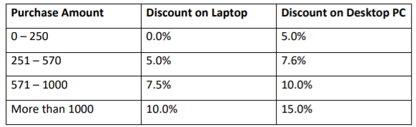  
Write a program based on the above criteria to input name, address, amount of purchase and type of purchase (L for Laptop and D for Desktop) by a customer. Compute and print the net amount to be paid by a customer along with his name and address.**

**Ans:**x = ‘Y’;  
while(x == ‘Y’ || x == ‘Y’)  
Name = input (‘Enter name here : ‘,”s”);  
Address = input (‘Enter address here : ‘,”s”);  
Amount = input (‘Enter amount here : $’);  
Types = input (‘Enter types of purchase (L for Laptop/D for Desktop) : ‘, “c”);  
if (Types == ‘L’)  
 fprintf (‘\nName: %s\n’, Name);  
 fprintf (‘Address: %s\n’, Address);  
 if (Amount>=0 && Amount<=250)  
 Discount = (0.0/100) * Amount;  
 Total = Amount-Discount;  
 fprintf (‘Net amount : $%.2f\n’, Total);  
 elseif (Amount>=251 && Amount<=570)  
 Discount = (5.0/100) * Amount;  
 Total = Amount-Discount;  
 fprintf (‘Net amount : $%.2f\n’, Total);  
 elseif (Amount>=571 && Amount<=1000)  
 Discount = (7.5/100) * Amount;  
 Total = Amount-Discount;  
 fprintf (‘Net amount : $%.2f\n’, Total);  
 else  
 Discount = (10/100) * Amount;  
 Total = Amount-Discount;  
 fprintf (‘Net amount : $%.2f\n’, Total);  
endif  
elseif (Types == ‘D’)  
 fprintf (‘\nName : %s\n’, Name);   
 frpintf (‘Address : %s\n’, Address);  
 if (Amount>=0 %% Amount<=250)  
 Discount = (5.0/100) * Amount;  
 Total = Amount-Discount;  
 fprintf (‘Net amount : $%.2f\n’, Total);  
 elseif (Amount>=251 && Amount<=750)  
 Discount = (7.6/200) * Amount;  
 Total = Amount-Discount;  
 fprintf (‘Net amount : $%.2f\n’, Total);  
 elseif (Amount>=571 && Amount<=1000)  
 Discount = (10.0/100) * Amount;  
 Total = Amount-Discount;  
 fprintf (‘Net amount : $%.2f\n’, Total);  
 else  
 Discount = (15.0/100) * mount;  
 Total = Amount-Discount;  
 fprintf (‘Net amount : $%.2f\n’, Total);  
endif  
 else  
 fprintf (‘\nInvalid type of purchase\n’);  
endif  
x = input (‘Do you wish to continue purchase : ‘,”c”);  
endwhile  
fprintf (‘You have exit purchase screen, Goodbye Thank You. ‘);